**GROUP ASSIGNMENT COVERSHEET**

**Decalaration**

(This declaration must be completed by all students in the group or the assignment will not be marked.)

We, the undersigned, certify the following:

* We have read and understood the *Student Academic Misconduct Policy*
* This assignment is our own work based on our personal study and or research.
* We have acknowledged all material and sources used in the preparation of this assignment including any material generated in the course of our employment.
* **The assignment has not previously been submitted for assessment in this or any other unit.**
* We have not copied in part or in whole or otherwise plagiarised the work of other students.
* We have read and understand the criteria used for assessment.
* The assignment is within the word and page limits specified in the unit outline.
* The use of any material in this assignment does not infringe the intellectual property / copyright of a third party.
* We understand that this assignment may undergo electronic detection for plagiarism, and an anonymous copy of the assignment may be retained on the database and used to make comparisons with other assignments in future.
* By completing this coversheet in full and submitting this assignment electronically, we are bound by the conditions of the KOI's *Student Academic Misconduct Policy* and the declaration on this coversheet.

|  |  |  |  |  |  |
| --- | --- | --- | --- | --- | --- |
|  | Family Name | Given Name(s) | Student ID | Tutorial Code | Signature |
| Student 1 | Bhetuwal | Amit | 1 2 1 0 0 6 6 8 | LAT2 |  |
| Student 2 | Baral | Hari Prassad | 1 2 0 0 1 6 2 8 | LAT2 |  |
| Student 3 | De Oliveira Dorneles | Luiz Filipe | 1 2 1 0 0 7 6 9 | LAT2 |  |
| Student 4 | Sukhbaatar | Binderiya | 1 2 0 0 1 8 6 4 | LAT2 |  |
| Student 5 |  |  |  | LAT2 |  |

Assignment Receipt

-

Unit Name: ICT204 Projecct Management T222

Assignment Title: PMBOK Assessment

Lecturer’s Name: Dave Unsworth

|  |  |  |  |  |  |
| --- | --- | --- | --- | --- | --- |
|  | Family Name | Given Name(s) | Student ID | Tutorial Code | Signature |
| Student 1 | Bhetuwal | Amit | 1 2 1 0 0 6 6 8 | LAT2 | AMIT |
| Student 2 | Baral | Hari Prassad | 1 2 0 0 1 6 2 8 | LAT2 | HARI |
| Student 3 | De Oliveira Dorneles | Luiz Filipe | 1 2 1 0 0 7 6 9 | LAT2 | LUIZ |
| Student 4 | Sukhbaatar | Binderiya | 1 2 0 0 1 8 6 4 | LAT2 | BINDERIYA |
| Student 5 | Soares Dias | Pedro | 1 2 2 0 0 7 3 6 | LAT2 | PEDRO |

GROUP ASSIGNMENT COVER SHEET * AUSTRALIAN INSTITUTE OF BUSINESS AND MANAGEMENT PTY LTD PAGE **1** OF **1**

13 JULY 2015 CRICOS 03171A ABN: 72 132 629 979

Executive Summary

This report is written in order to assemble and implement a CMS-based donation tracking site for NSW Rural Fire Service which is re-usable later on by other states too without causing any loss of data and while adding some additional features. In this report, the foundation or the paperwork for the development of the CMS has been laid. The project charter, project scope, WBS, Stakeholder register and other necessary documents has been presented in this document. These documents are prepared while keeping the requirement provided in the Case study into consideration, and the approach taken in order to build the CMS is agile approach. The system will be implemented while preserving the present customers’ data. The scope of this project mainly aims on Work Breakdown Structure, under which tasks are divided to different team members on the basis of their role. And to ensure the project does not go overbudget, the project budget has also been prepared which provides an overview of the overall cost, resources that has been and will be used, percentage of work done, and the timeline of the project and more. The CMS will also have an advanced security system that will be placed along with an automatic backup system.

Table of Contents

Project Charter 5

PROBLEM STATEMENT 5

REQUEST DESCRIPTION 5

Goal and Objectives 5

Business Benefits 6

Stakeholders Affected and Type 6

PROJECT APPROACH 6

Main project success criteria 7

SCHEDULE SUMMARY 7

ROles and Responsibilities (Partial List) 8

Review & AuthorisationS 8

Project scope 9

PROJECT TITLE : DONATIONS WEB 9

stakeholder registration 11

Risk Register 13

Work Break Down Structure 15

Gantt Chart 16

Project Budgett 17

Conclusion 18

Member Participation 19

REFERENCES 19

# INTRODUCTION

NSW Rural Fire Service wants us to create a new website to replace the current website that is being used by them for tracking donations at the moment. Their demand is to track the donation and archive the donor files for future actions such as sending the file to the ATO as the donation collected by them are tax-deductible charities. They want to have some other new features on the CMS along with the website accepting multiple forms of payment, daily backup and more. This paper contains the Project report, stakeholder register, WBS, Project Budget and other important documents. These documents need to be approved by respectable parties.

Project Charter

|  |  |  |  |
| --- | --- | --- | --- |
| Company | NSW Rural Fire Service | | |
| Project Name | Implement a website for tracking donations | | |
| Project Description | NSW Rural Fire Service wants to allow the collection of donations from other states too without losing the data of the current donators and with some other new features. So, a CMS needs to be developed while meeting their needs. | | |
| Time Frame | 3 months | | |
| Budget | AUD 750k | | |
| Date Of Authorization | 21/07/2022 | | |
| Project Start Date | 24/07/2022 | Project End Date | 24/10/2022 |
| Client Contact | Amit Bhetuwal | Version No. | V 0.1 |
| Client Email Address | amitbhetuwal@gmail.com | Phone | 0483845326 |
| Project Manager | John Wills | Phone | 0489282929 |

## PROBLEM STATEMENT

NSW Rural Fire Service is planning to expand its donators scope outside NSW to other states too, but the current system used by NSW Rural Fire Service has not been enough to meet its growing demand. So, they have contacted us to develop a new CMS for them which can meet their requirements.

## REQUEST DESCRIPTION

### Goal and Objectives

1. Build, test, and implement a Content Management System/Extranet website for tracking donations.
2. The website needs to be reusable later on by other customers in other states for NSW Rural Fire Service to keep track of donations.
3. To have the system be fully available on robust infrastructure in a cloud network
4. The CMS needs to send donor files to ATO with amounts every tax year about 1 month after tax year.
5. Install proper advanced security that is appropriate for the extranet site.
6. The CMS to have data of previous donner too.
7. The website needs to do backup daily automatically.
8. The CMS needs to accept multiple forms of payment including cheques.
9. The CMS generates reports about donors/customers in full detail.

### Business Benefits

1. The business will have a CMS-based website which will be re-usable in other states, allowing the donations to come from all over the country.
2. The business will accept multiple forms of payment allowing for a rise in revenue.
3. The business will have a more secure environment due to advanced security.
4. The automatic backup of data will allow the business to have customers’ data even in case of data corruption.

### Stakeholders Affected and Type

1. Program Manager (Major Stakeholder)
2. CEO of NSW Rural Fire Services (Major Stakeholder)
3. Business Analyst
4. Consultant
5. ATO
6. Programmer

## PROJECT APPROACH

Description listing most salient aspects:

1. Meet with clients and define the system requirements
2. Plan the project and team structure
3. Using the Agile approach to implement a new CMS to track the donations of NSW Rural Fire Service
4. Design, develop, test, and refine the solution.
5. Provide training to users and receive feedback and recommendations for improvements.

## Main project success criteria

Description listing most salient aspects:

1. All the required modules mentioned in Case Study are completed and the needs are fulfilled.
2. The past data of donors is not lost.
3. The security of the CMS is proper and the CMS is usable in other states too.
4. The CMS should backup the data daily.
5. The Project is completed within the timeline of 3 months as per the deadline.
6. The CMS is completed under the budget.

## SCHEDULE SUMMARY

| Milestones | Date | Status | Comment |
| --- | --- | --- | --- |
| Develop Project Charter | 24/07/2022 | Completed | Reviewed with the team |
| Identify Stakeholders | 31/07/2022 |  |  |
| Draft the Risk register | 03/08/2022 |  |  |
| Completion of WBS | 07/08/2022 |  |  |
| Collect user inputs | 15/08/2022 |  |  |
| Design the system | 30/08/2022 |  |  |
| Develop and test the system Integrate past data with the system | 25/09/2022 |  |  |
| Integrate past data into the CMS | 30/09/2022 |  |  |
| Software installation, resources for doing donations already | 07/10/2022 |  |  |
| Install advanced Security | 14/10/2022 |  |  |
| Implement the system | 20/10/2022 |  |  |

## ROles and Responsibilities (Partial List)

| Name | Role | Position | Contact Information |
| --- | --- | --- | --- |
| Sharon Ellicott | Sponsor | NSW Rural Fire Service, CEO | sharoneilicott@gmail.com |
| Amit Bhetuwal | Project Manager | XYZ PTY Ltd, manager | amitbhetuwal@gmail.com |
| Sam wills | Quality Manager | XYZ Pty Ltd, manager | samwills@gmail.com |
| Joe Rich | Team Member | XYZ Pty Ltd, Consultant | richjoe@gmail.com |
| Luiz Filipe De Oliveira Dorneles | Team Member | XYZ Pty Ltd, IT department | Luiz20@gmail.com |
| Sukhbaatar Binderiya | Advisor | Client Representative | Sukhbaatar32@gmail.com |
| Hari Prasad Baral | Team Member | XYZ Pty Ltd, IT department | hariprasad@gmail.com |

## Review & AuthorisationS

| Reviewers | Name | Date | Signature |
| --- | --- | --- | --- |
| Quality Manager | Sam Wills | 24/08/2022 | Sam |
| Project Manager | Amit Bhetuwal | 24/08/2022 | Amit |
| Client Representative | Sukhbaatar Binderiya | 24/08/2022 | Sukhbaatar |

## Project scope

This section hass been presented by the Project Manager outlines the entire project along with the objectives of the project and its’ deliverables and their features (Lanadau, 2019). The project involves the implementation of a website for donations from NSW Rural service. The implemented system should be able to do donations and provide advanced security to all the system users. The proposed CMS should be capable of overlapping with some issues for example so many donations at the same time. The tracking of the donations should be provided to the CRM portal online and be accessible to donors.

## PROJECT TITLE : DONATIONS WEB

**Project summary and justification**

* Client information will be imported into both the CRM and MMS frameworks
* Record the arrangement utilized for CRM and MMS at Xyz PTY Ltd.
* The client site will want to have a climate where Xyz PTY Ltd. and their clients will be ready to raise and track IT issues with the execution of CRM arrangement
* Xyz PTY Ltd. staff ought to have the option to remotely get to the PCs at the client site utilizing the MMS framework
* The following of the relative multitude of clients who have finished onboarding is conceivable in the CRM and MMS frameworks
* The proposed framework ought to have the option to cover the ongoing arrangement
* The carried-out frameworks ought to be furnished with security
* Online admittance to the CRM gateway in the proposed answer for the following the advancement of receipt and donations.
* Summary of projects deliverables
* Project The executives - Related expectations:
* Business Case - Catches the thinking for starting a venture or errand.

**Project Contract - Proclamation of degree goals and individuals who are taking part in a project.**

* Group contract - A report will be endorsed in the commencement of the undertaking to distinguish working gatherings.
* WBS - Work Breakdown Construction - A key undertaking deliverable that coordinates the group's work into reasonable areas.
* Scope Articulation - Recognize the principal expectations and targets of the undertaking. Moreover, incorporates a financial plan and achievement.

## stakeholder registration

|  |  |  |  |  |  |  |  |  |
| --- | --- | --- | --- | --- | --- | --- | --- | --- |
| ID | NAME | TITLE | ROLE | POWER  (H/L) | INTEREST  (H/L) | REQUIREMENTS | CONCERNS | CONCERNS MITIGATION MEASURES |
| 1 | Sharon Ellicott | CEO | Sponsor | H | H | Project completion while adhering to the specification and deadline | Not exceeding the allocated budget; Increase in sales after implementing CMS | Select a company that has a good track record and is trustworthy, and has done similar projects in the past. |
| 2 | Amit Bhetuwal | Project Manager | Project Head | H | H | Up-to-date information about everything related to the project | Related bodies’ understanding of the project | Communication of information with various people working on the project from time to time via a communication channel. |
| 3 | Hari Prasad Baral | Developer | Developing the project | H | H | Developing the project | Developing the CMS within the required time with no errors. The resources of the company. | Providing devices and everything needed to the staff required for developing the project. In case pressurized on completion of the project; the developer is available in backup. |
| 4 | Sam wills | Quality Manager | Tester | L | H | Setting up the testing area, and testing the CMS. | The quality of the CMS | Communicate with the developer about the quality of the project and in case there is any problem inform the project manager. |
| 5 | Luiz Filipe De Oliveira Dorneles | Designer | Designing the project | L | H | Designing the Project | The design is approved by stakeholders | Do the research, ask the stakeholders about how they want the CMS to look; and on the basis of that create a UI/UX design. |
| 6 | Angelique Gates | Co-coordinator | Generating and Distributing report | L | H | In-depth familiarity with the project | Functioning as a general assistant to the management | Make sure every piece of information and action that is happening in relation to the project, goes through her. |
| 7 | Alexander Smith | N/A | Supplier | H | L | Provides adequate lead times with timely payment | The buyer wants a decrease in the cost price. Damage to equipment during delivery. | Insurance the equipment and sign a contract with the person in charge of the project. |
| 8 | Sukhbaatar Binderiya | Administrator | Supporting the customers | L | L | IT help desk formation | Lack of human resource | Publish advertisements, and hire eligible people. |
| 9 | Justin Marcus | Accountant | Handling the accounts related to project | L | L | - | Expenses and revenue are reported with receipts. | When a receipt is not received, inform the coordinator and the project manager. |
| 10 | Joe Rich | Head of Sales | Managing the revenue | L | L | Functioning of the software and users’ reaction to it. | Lack of budget | Hold a stakeholder meeting; gather various ways to deal with the situation and choose the most appropriate one. |

## Risk Register

|  |  |  |  |  |  |  |
| --- | --- | --- | --- | --- | --- | --- |
| ID | Risk Description | Impact level of Risk | Impact of Risk | Mitigation Action | Contingency Action | Risk Owner |
| 1 | The not well-defined mentioning of project requirements | High | Pushes deadline and overbudget expenditure. | Ensure that the business case is well defined in Project Charter. | -- | Project Sponsor |
| 2 | Supplier Delay | High | Pushes Deadline. | Confirm the delivery dates by September | Mention in the contract that no matter the reason, the supply has to be delivered under the deadline. | Supplier |
| 3 | Unplanned work that has to be done | High | Overbudget Expenditure and pushes the deadline. | Check past similar projects for determining actual work and costs.  Document all of the assumptions made during the planning phase and communicate to the Project Manager before kick-off of the project. | Hold meetings with the Client and all of the major stakeholders and discuss what to do for things that are needed but not planned or mentioned in the project charter | Project Manager |
| 4 | Promotion of the CMS | High | Causes less Customer traffic and less revenue after project implementation. | Start the promotion of the project early on while showcasing the benefits of the project while the project is still under-development | Ensure that the promoted qualities are the ones that the client wants. | Project Sponsor, Project Manager |
| 5 | Providing training for customers and IT Staff | Medium | Some benefits of the System remain unexplored. | Promote the feature of CMS while creating a self-explanatory video so the staff can learn by themselves | Ensure that all of the staff have watched the self-explanatory video and provide them with a way to get assistance if required. | Project Manager,  Advertising Department |
| 6 | Legal action delays or pauses of project | Medium | Unsatisfaction of Sponsor, Pushes deadline. | Before starting the project, make sure all regulatory requirements are under the law. | Ensure all contracts are signed. | Project Manager |
| 7 | Theft of materials | High | Over expenditure of budget. Pushes deadline | Adoption of proper security measures. | Ensure there is the insurance of materials. | Project Manager, Security Technician |
| 8 | Acts of God | High | Delay in project completion. Loss of materials. Over expenditure of budget. Loss of data. Loss of life. | Follow Safety procedures. Follow safety procedures. Ensure data backups are in place. | Ensure the insurance covers the Act of God. Familiarize the staff with emergency measures. | Project Sponsor, Project Manager,  Insurance Company |
| 9 | Lack of Cooperation or delay in the work by stakeholders | High | Internal feuds causing delays in project completion. | Identify stakeholders, and create intervals to ensure that all stakeholders are managed. | The contract should mention providing full co-operation with the project by the stakeholders. | Project Manager |
| 10 | Lack of cooperation between staff | High | Internal feuds between staff or departments resulting the delay of the project’s completion. | Correct any misunderstandings immediately. Create a proper communication plan and ensure the stakeholders are in the communication. | Use appropriate communication channels like Gmail, and zoom for holding meetings. | Project Manager |

## Work Break Down Structure

A visual project breakdown is called a work breakdown structure (WBS). The WBS starts with the scope of work and then displays the deliverables and how they relate to the main project. A work breakdown structure may be made using both project management frameworks and workflow management software because it is clearly shown. Calendars, and timelines are a few of these techniques.

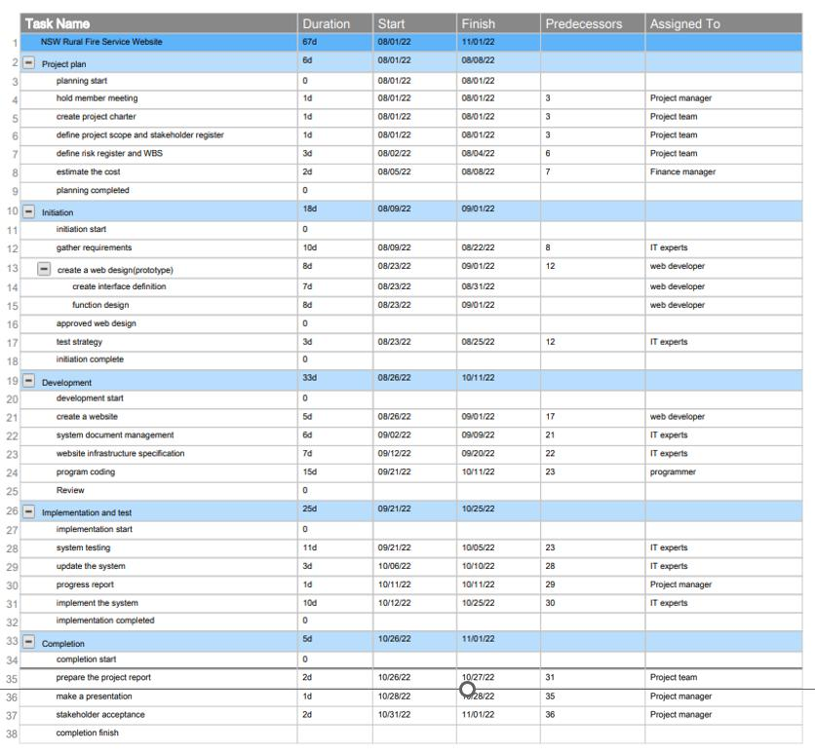

## WBS DICTIONARY

|  |  |  |
| --- | --- | --- |
| Task | Description | Responsible person |
| 1. Planning |  |  |
| Hold member meeting | Create meetings requirements | Project Manager |
| Create project charter | The environment in the project | Project Team |
| Define project scope and ‘ stakeholder register | Important information about the tasks | Project Team |
| Define risk register and k WBS | Minimize Risks and control spending | Project Manager |
| Estimate the cost | Budget | Finance Manager |
| 1. Initiation |  |  |
| Gather requirements | Process of gathering system requirements and stakeholder requirements of the project | IT Experts |
| Create a web design | 1. Design a user interface to fill in the name, and address fields. 2. Create functions to produce receipts, make reports, and send donor files to ATO. Create payment options (monthly, one-off, indefinite period) and methods (credit card, PayPal, cheque). | Web developer |
| Test strategy | An important test for running a website | IT Experts |
| 1. Development |  |  |
| Create a website | Clients can access for donations | Web Developer |
| System document w  odds management | Link existing websites to get details of existing donors, archive the information of new donors, and assign a unique ID for the donors. | IT Experts |
| Website Infrastructure  ; the specification | Deploy secure robust infrastructure in the cloud | IT Experts |
| Program coding | Back-end creating Developing | Programmer |
| 1. Implementation and testing |  |  |
| System testing | Testing the system so that it can be observed that it will run correctly | IT Experts |
| Update the system | having updates there will be an improvement in the server and system | IT Experts |
| Progress report  In | Make a report about the work done | Project Leader |
| Implement the system | put to run the system after analyzed and tested | IT Experts |
| 1. Completion |  |  |
| Prepare the project report | Reviewing the project's readiness to be spun off for stakeholders | Project Team |
| Make a presentation | Presentation for the Stakeholders | Project Manager |
| Stakeholder acceptance | Understanding the project and tasks. | Project Manager |

## Project Schedule (Developing)

The project schedule has been planned as shown in the diagram below. At the time of publishment of the report only the project initiation date has been fixed. As per the foreseen situations and preparing for any unforeseen circumstances, the possible project completion date has been also planned.

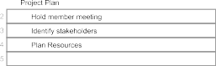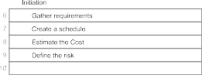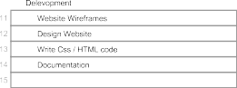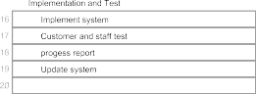

## Gantt Chart

Under the Gantt chart, the flow of activities is presented coordinated with the flow of time. (Gantt.conn, n.d).

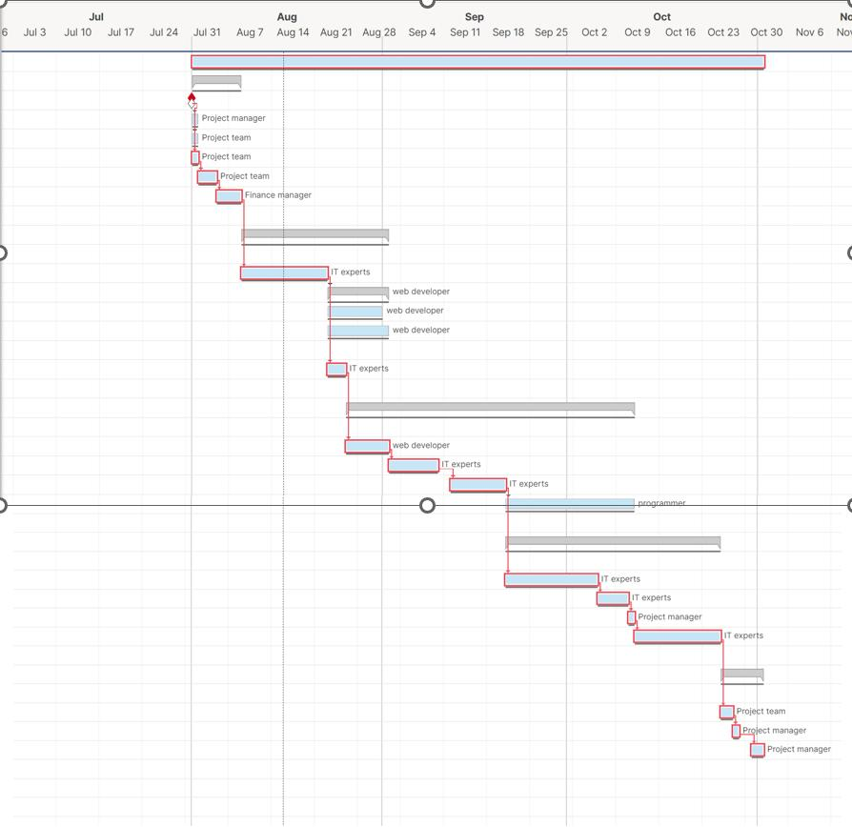

## Project Budgett

This section estimates the overall project cost that is expected to happedn, and this is a tool that is used by Project Managers (CFI, n.d.). The project can sometime cross the budget and sometime, it can be finished under the budget. So the project budgett is more of a structure that provides the expected expenses on the basis of the expense rate that is in the market at the moment.

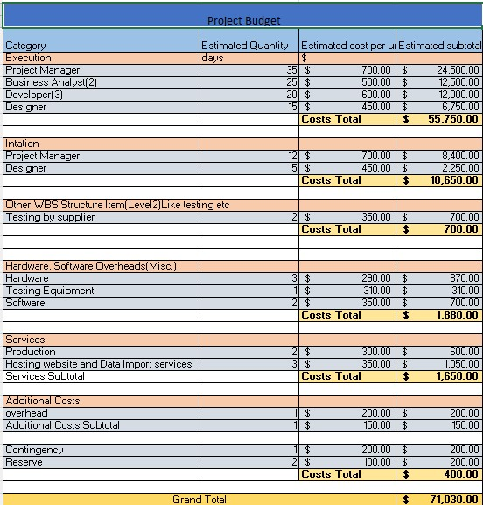

## Conclusion

The project “Donation Tracking” has displayed the overall planning that is required in order to commence the building of CMS for NSW Rural Fire Service. Before commencing the project, all of the accessible data has been analysed and all of the unforeseen situations that can occur have been taken into consideration. During the building of the CMS, all things might not go as planned and some unforeseen situation obstacles might have to be faced. But if the CMS building is carried out according to this plan, such unforeseen disasters are likely to not appear, and in case any particular situation appears, it can be easily taken care of. Various reports like WBS, project budget, stakeholder register and many more have been created to ensure that the project is finished on time while meeting all of the requirements mentioned in the Case Study.

## Member Participation

|  |  |  |  |  |
| --- | --- | --- | --- | --- |
|  | Family Name | Given Name(s) | Student ID | Participation |
| Student 1 | Bhetuwal | Amit | 1 2 1 0 0 6 6 8 | 100% |
| Student 2 | Baral | Hari Prassad | 1 2 0 0 1 6 2 8 | 100% |
| Student 3 | De Oliveira Dorneles | Luiz Filipe | 1 2 1 0 0 7 6 9 | 100% |
| Student 4 | Sukhbaatar | Binderiya | 1 2 0 0 1 8 6 4 | 100% |
| Student 5 | Soares Dias | Pedro | 1 2 2 0 0 7 3 6 | 100% |

## REFERENCES

CFI, n.d. Project Budget Manage the costs of a project. CFI [online] Available at: <[https://corporatefinanceinstitute.com/resources/knowledge/finance/project-budget-overview/](https://corporatefinanceinstitute.com/resources/knowledge/finance/project-budget-overview/%20) >[Accessed 16 August 2020, 19:17].

Landau, 2019. Project Scope Statement: Include These 7 Things. Project Manager, [online] Available at: < <https://www.projectmanager.com/blog/project-scope-statement>> [Accessed 16 August 2020, 19:32].

Gantt.com, n.d. What is a Gantt Chart? [online]. Available at: < https://www.gantt.com/ > [Accessed 16 August 2020, 20:17].